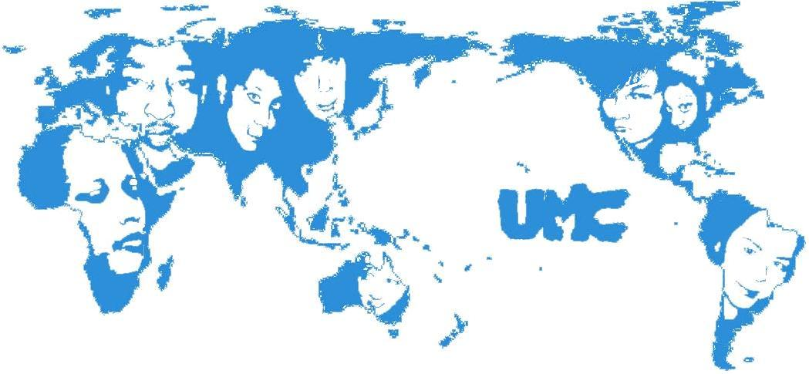
UMC General Body Meeting
Wednesday, March 5, 2008

Introductions, Sign-In & Refreshments

First Forum—20 minutes
- Political engagement and civic duty (UMC board & Penn Leads the Vote)
  - Jonathan Gertman, Penn Leads the Vote (gertman@sas.upenn.edu)
  - Pennsylvania primary: April 23
  - Last day to register: March 24
  - Lack of minority voters discussion
    - Idea of “My vote doesn’t count” and “It will make no difference” because representatives’ issues do not align with their own concerns
    - Unclear instruction of the process of voting, registration etc.
    - May vote, but is it for the right reasons?
    - Apathy?
    - Satisfaction with the status quo in terms of socioeconomic status, culturally, community
    - Some improvements which should increase minority youth voting:
      - Identification of minority youth as “American”
      - Voter registration on the walk
      - making polling easier and more convenient (in-dorm etc.)
    - What can we do in the future?
      - Being politically cognizant now can lead to change in the ethnicity of politicians
      - Educating students about political issues: issue awareness, candidate awareness

Updates—10 minutes
- UA Steering (Lorenzo)
  - Postal lands development plan for the Arch
    - Architect chosen, plans coming in spring
  - Environmental sustainability at Penn
- University Council (Lisa)
  - Minority faculty recruitment and retention update
  - +13 asian faculty, -3 black
- UA Budget meeting (Lisa)
- Lunch with President & Provost (Derek, Lorenzo)
  - Campus climate, dubois/arch renovation, faculty retention and recruitment addressed
  - Meeting with VP facilities
- 5B Meeting (Derek)
  - same 3 issues being pushed across the board and showing a united front
- Division of Public Safety (Derek, Sonie)
  - Confused on how to respond to the text
  - Audit compliance
    - Educate students about privacy and identity theft
    - Partner with UMC, UA, GAPSA, PAC groups
    - Video, brochures, website
- New Treasurer (Rich)
- Intercultural Fund Retreat (Rich)
  - Attempt at strong intercultural vibe between coalitions (5B)
  - Mission statement
  - Temporary suspension (rechartering constitution)

WED MARCH 26, 4-6pm. Open forum University Counsel!!!
“RSVP”

UMC Super Stars (NEW feature!)
- Grupo Quisqueyano (Calina)—2 minutes
  - Study Break event—Independence Day, Feb 27

New Business
- Campus Climate Discussion follow-up (UMC board)—5 minutes
  - Blurb handed out, drafted with Lambda alliance
  - Look to 3 “solitions”
  - Want to ask direct questions on climate (rather than inferring from numbers)
  - Focus groups to brainstorm issues we want to ask about
- Programming Events (Sonie, Janice, Liz)—15 minutes
  - UMC Restaurant Night
Thursday, March 27, 2008
8 PM, Restaurants & BYO’s across Philadelphia
RSVP to unitedminoritiescouncil@gmail.com about dietary restrictions and drinking preferences
  - Celebration of Cultures & UMC’s 30th anniversary (April 17th)
    - How can we make the whole process more integrative?
    - How can these events be improved or fleshed out?
    - Please submit forms online to your liaisons!
  - Nighttime event: committee sign up
    - Tickets and publicity
    - Decorations and Food
    - Entertainment and programming
  - Invited founder of GIC to speak

Announcements—8 minutes

EMAIL GUPTEB@WHARTON.UPENN.EDU TO ANNOUNCE YOUR EVENTS!!!

Club Singapore looking for a group to collaborate with for a foam party, March 29th. Email seek@sas.upenn.edu for more info.

